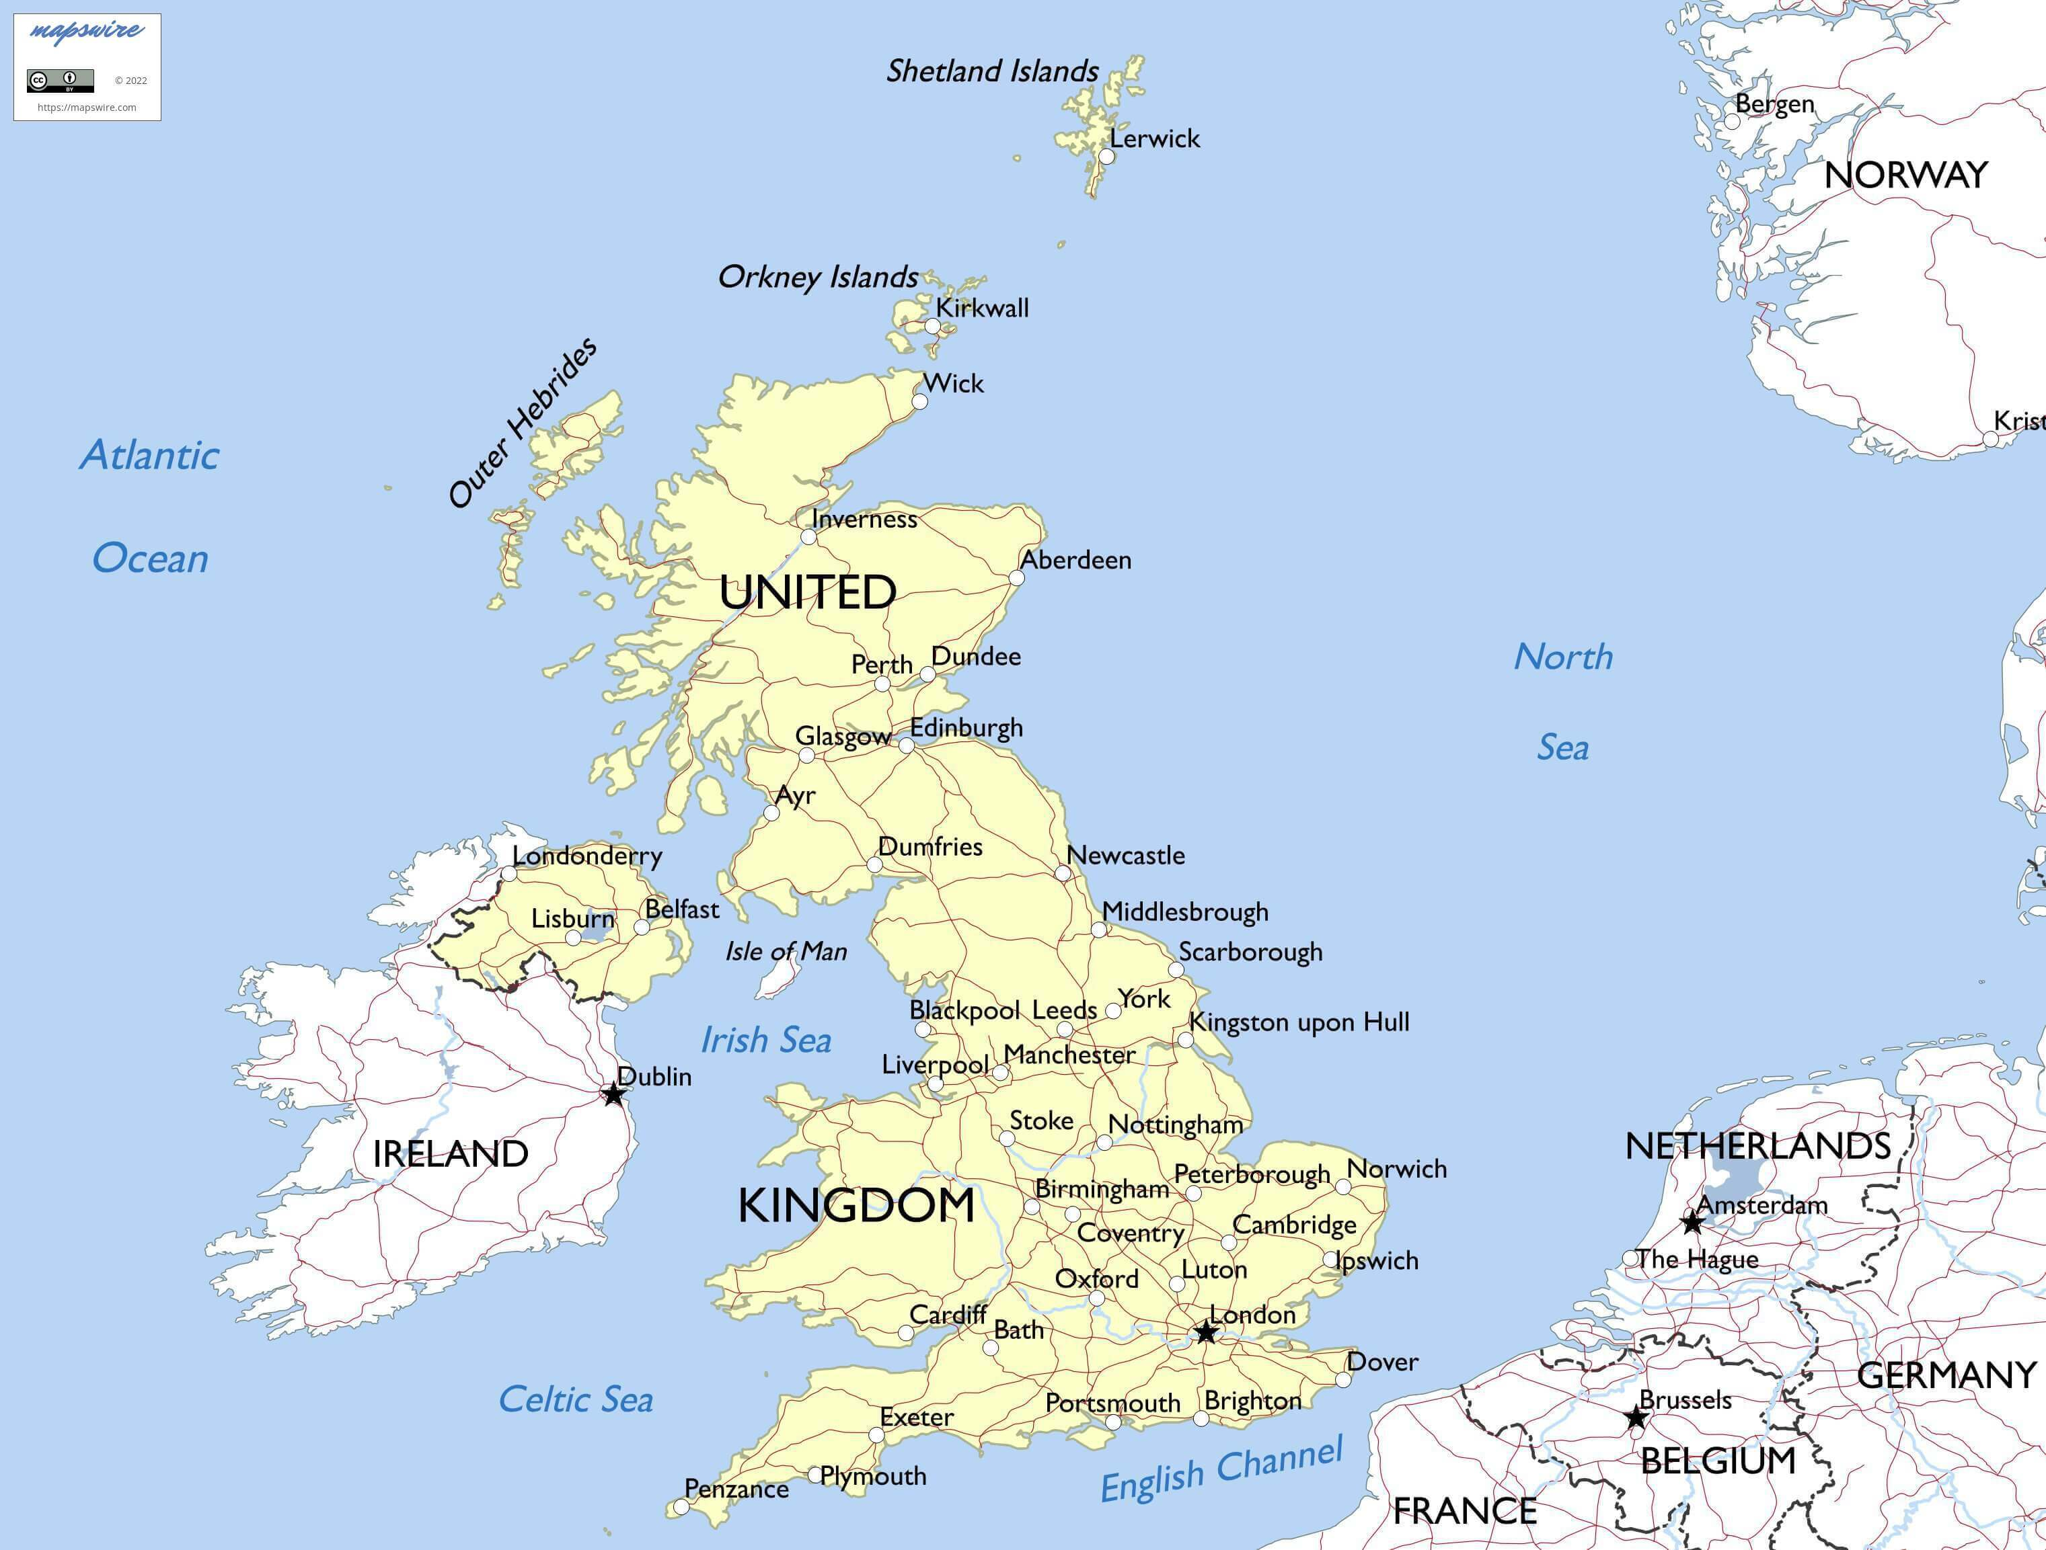

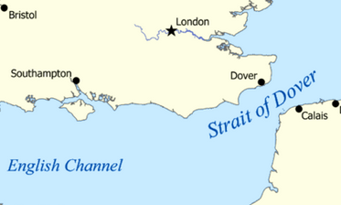 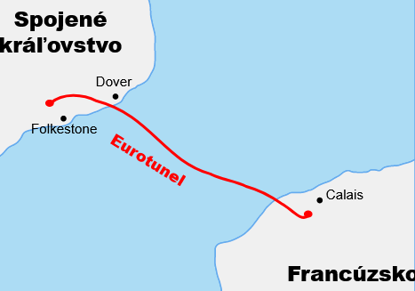

1. **LOCATION and CHARACTERISTICS of Great Britain**

**The United Kingdom of ....Great.. ..Britain... and ..Northern .. ..Ireland.... (UK)**

consists of (....England......., ...Scotland...., ..Wales...., ....Northern Ireland......)

**Great Britain** comprises ....... England......., ...Scotland.... and .......Wales......... .

**POLITICAL SYSTEM:**

**Constitutional monarchy**..: the monarch exercises their authority in accordance with a constitution and is not alone in decision making **AND**

**Parliamentary democracy**...... a system of democratic governance of a state.

**HEAD OF STATE**: Monarch: King Charles III........... Until 2022: ....Queen Elizabeth II...................

Prime Minister: Rishi Sunak

**THE FLAG:** called the **.Union Jack..** is made up of 3 crosses symbolizing 3 older national flags**.** the red cross of [St George](https://en.wikipedia.org/wiki/St_George) for the Kingdom of England, the white saltire - šikmé- of [St Andrew](https://en.wikipedia.org/wiki/St_Andrew) for [Scotland](https://en.wikipedia.org/wiki/Scotland) and the [red saltire](https://en.wikipedia.org/wiki/Saint_Patrick%27s_Saltire) of [St Patrick](https://en.wikipedia.org/wiki/St_Patrick) to represent [Ireland](https://en.wikipedia.org/wiki/Ireland).

**ANTHEM**: ......**God save the King**........

**POPULATION**: ......**67**..............million (2020), multiethnic population

**LOCATION:**

**The total area** of the United Kingdom is approximately **244,820** square kilometres. The country occupies the major part of the ...**British Isles**.... . It is surrounded by**... the Atlantic Ocean** and ....**the North Sea**..........

**The natural border** the ....**English Channel**.... separates Great Britain from .....**France**/continental Europe. . .**The Strait of Dover** is the [strait](https://en.wikipedia.org/wiki/Strait) at the narrowest part of the [English Channel](https://en.wikipedia.org/wiki/English_Channel). French name is: **la Manche**. Towns **Dover** and **Calais** are connected by ferries.The **Channel Tunnel** is the longest underwater ...**railway**.... tunnel in the world (50km).

**Neighbour countries**: **.....Ireland**...... on the west, **...France**..... on the southeast.

**LARGEST CITIES:**

**England**:...London, Birmingham, Manchester, Liverpool...............................

**Wales**:..Cardiff............................................................................................

**Scotland**:....Glasgow, Edinburgh, Aberdeen................................................

**Northern Ireland**: ..Belfast, ..............................................................................

**RIVERS**: ..Thames (London), the longest river in England **Severn**, Mersey, Tyne, ...........

**LAKES**: .. the largest is [**Windermere**](https://en.wikipedia.org/wiki/Windermere) in the [Lake District](https://en.wikipedia.org/wiki/Lake_District). Inverness, with a famous creature Nessie- Loch Ness

**LANDSCAPE**: low hills and plains, with uplands **Pennines** and mountainous terrain in the north and west of the country. The [**English Lowlands**](https://en.wikipedia.org/wiki/English_Lowlands_beech_forests) are in the central and southern regions of the country, the form green rolling hills, where they meet the sea they form white rock exposures such as the [**cliffs of Dover**](https://en.wikipedia.org/wiki/Cliffs_of_Dover)**. The Highlands -** area in Scottland with many[mountain ranges](https://en.wikipedia.org/wiki/Mountain_range) including the highest mountain in the [British Isles](https://en.wikipedia.org/wiki/British_Isles), **Ben Nevis**........(1,345m)**.**

**CLIMATE:** has a temperate climate with **mild** and **wet** weather that changes a lot. The Gulf Stream brings mild winters (temperatures seldom dropping under 0°C)

1. **PARTICULARITIES OF THE COUNTRY:**

**THE BRITISH** are said to have a strong sense of tradition, they are proud of their country, they loved the Queen (the King ?). They admire and support the Royal Family, they often talk about the weather, they drive on the left, i tis said it always rains in the UK, 40% of people own a pet, even while beeing a member of the EU they kept their currency- The Pound Sterling

**SCOTLAND** - country full of traditions: playing bagpipes, wearing kilts (pleated knee-length tartan skirt), drinking Scotch whisky, patriots, believe in Nessie

**Holidays- St. patrons Days** - St. Patrick’s Day in Ireland, Guy Fawkes Night

**Christmas-**

**Easter-**

1. **PEOPLE’S LIFESTYLE:**

**tea at 5-**

**sport-** fond of football, rugby, cricket, tennis, golf, horse race, petang

**schools-** uniforms, ABC, ...

**housing-**

**free time-** often go for picnics,barbecue